**Week 5 Module 7.2 Assignment**

Juan Macias Vasquez

Bellevue University

CSD325-H323 Advanced Python (2255-DD)

**Jack Lusby**

June 28th, 2025

Module 7.2 Assignment: Country Population and Language

Results Document

Part 1 Code and Screenshot

# Juan Macias Vasquez

# Date 06/27/2025

# Module 7.2

# city_functions.py

def city_country(city, country):

result = f"{city.title()}, {country.title()}"

return result

# Call the function three times with different combinations

print(city_country("santiago", "chile"))

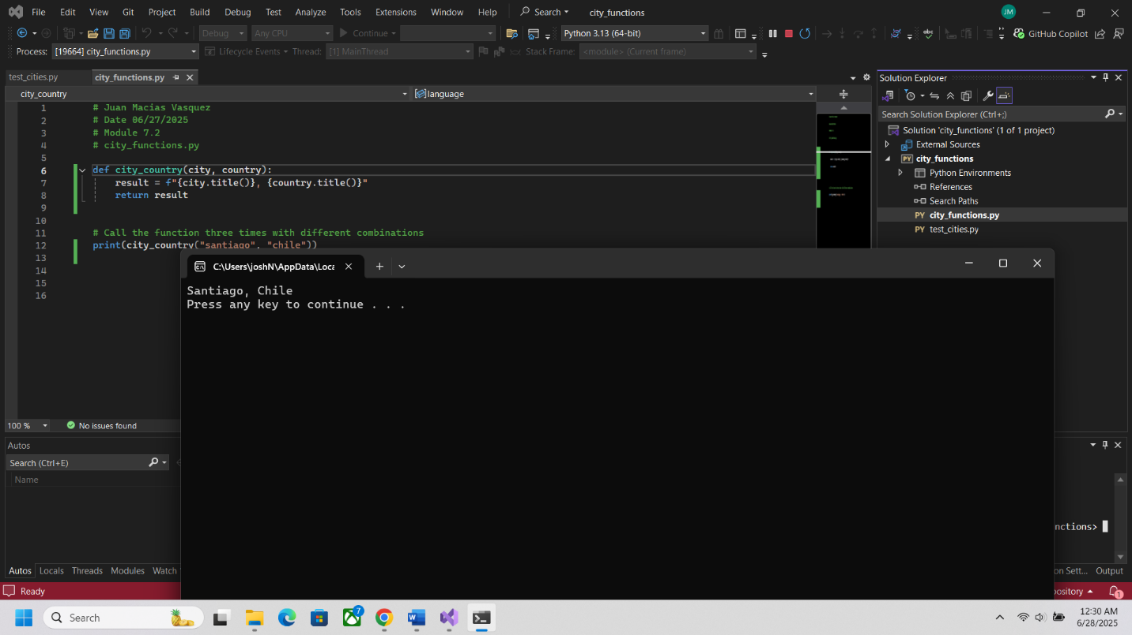

Part 2

# Juan Macias Vasquez

# Date 06/27/2025

# Module 7.2

# test_cities.py

import unittest

from city_functions import city_country

class CityCountryTestCase(unittest.TestCase):

def test_city_country(self):

formatted = city_country('santiago', 'chile')

self.assertEqual(formatted, 'Santiago, Chile')

if __name__ == '__main__':

unittest.main()

Picture 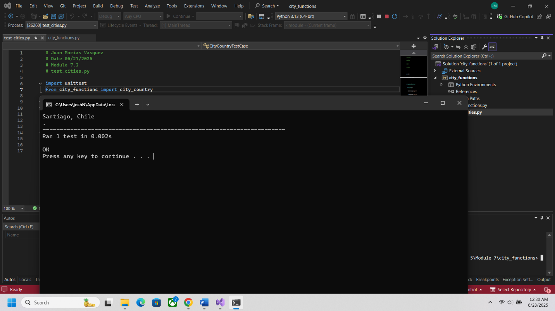

Part 3

Changed city country To

def city_country(city, country, population):

return f"{city.title()}, {country.title()} - population {population}"

Picture from City Functions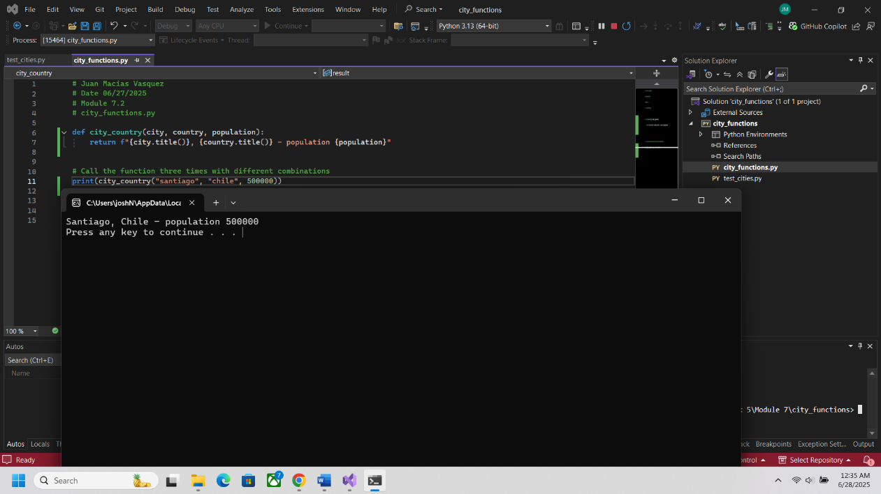

 test_cities.py fail at part 3

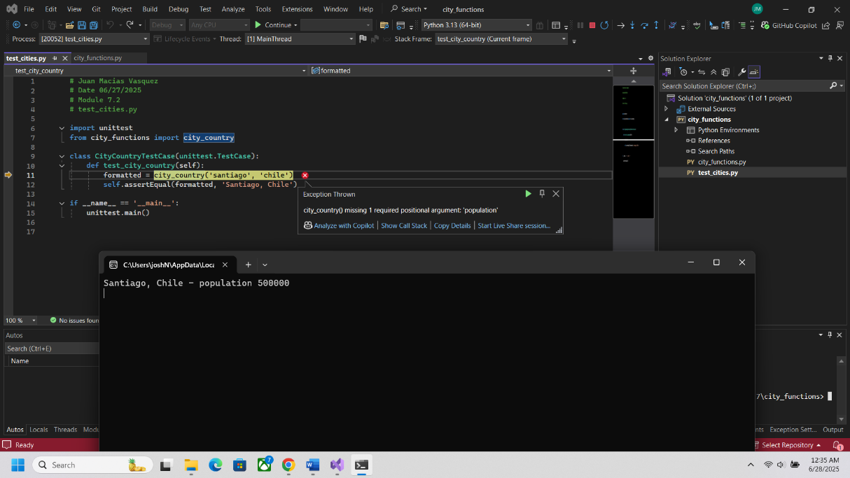

Part 4

Changed City Functions To make population optional

def city_country(city, country, population=None):

result = f"{city.title()}, {country.title()}"

if population:

result += f" - population {population}"

return result

Picture from it working now in test cities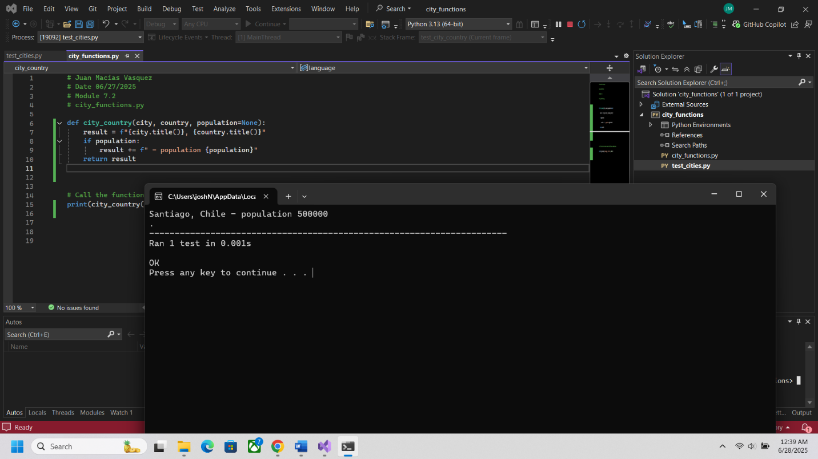

Part 5

Updated Function to make a language parameter

def city_country(city, country, population=None, language ):

result = f"{city.title()}, {country.title()}"

if population:

result += f" - population {population}"

result += f" {language.title()}"

return result

Picture from City Functions

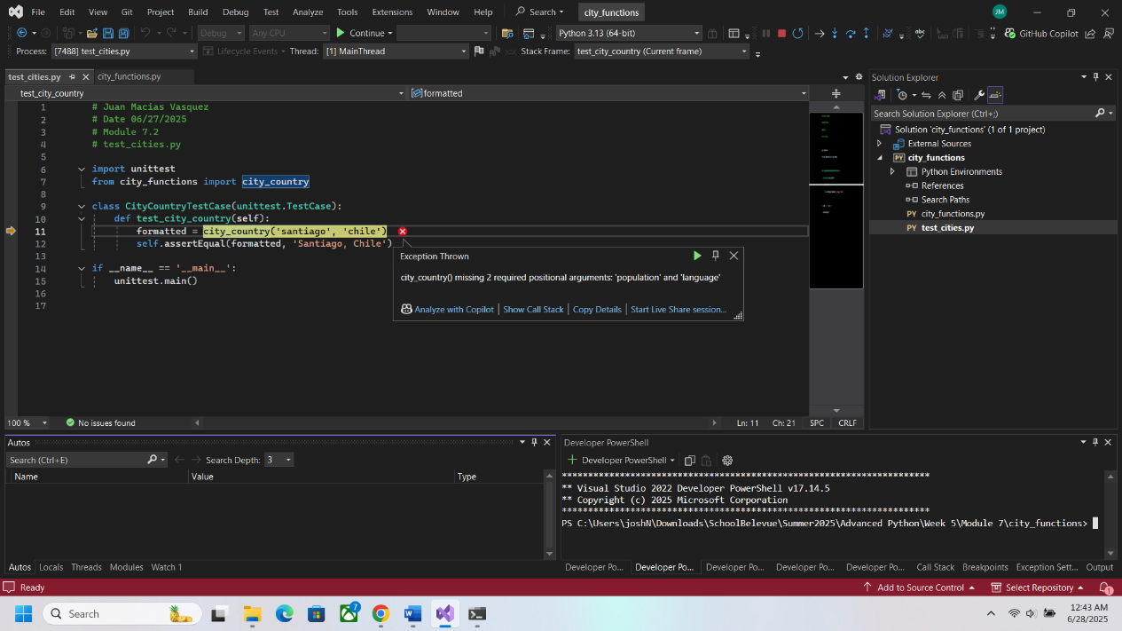

Picture of Test cities failing

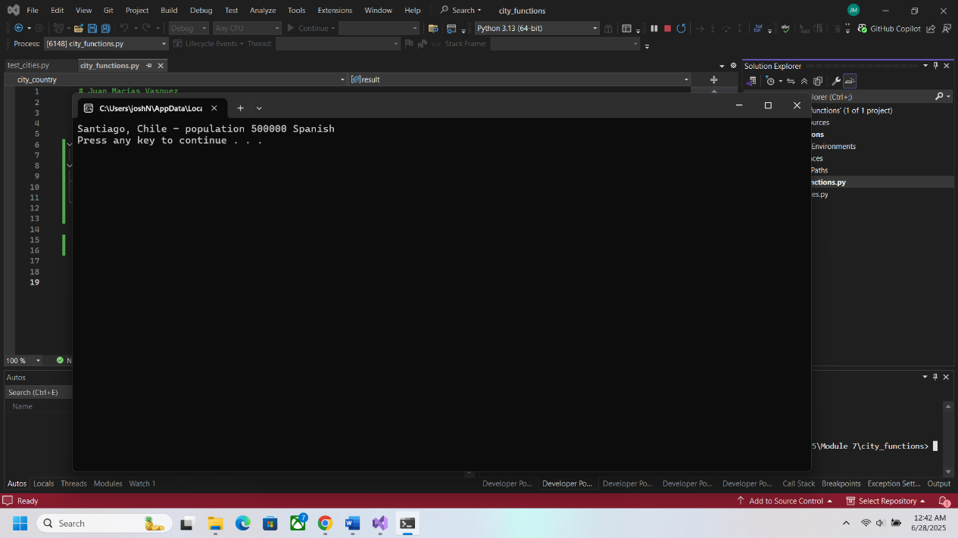

Part 6

Made Language parameter optional

def city_country(city, country, population=None, language=None):

result = f"{city.title()}, {country.title()}"

if population:

result += f" - population {population}"

if language:

result += f", {language.title()}"

return result

Picture of Test cities now working

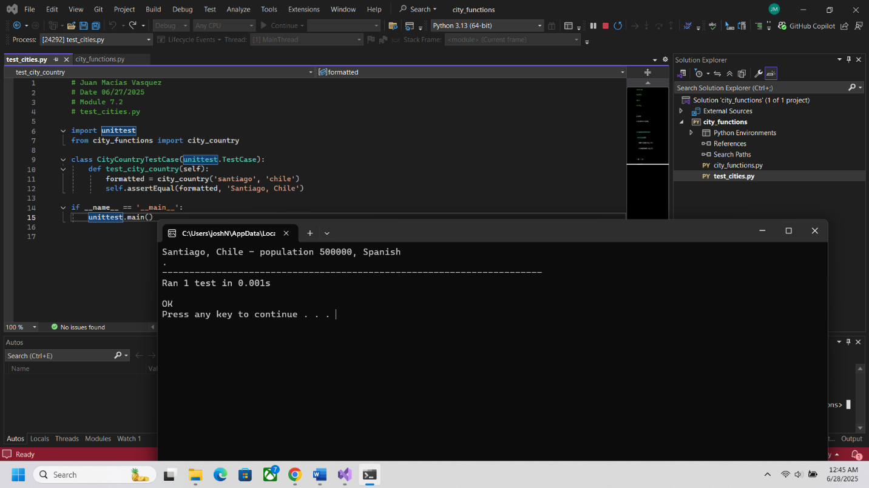

Part 7 Final

Adding three different countries with different parameters

